# Return Distribution Plotting in Python

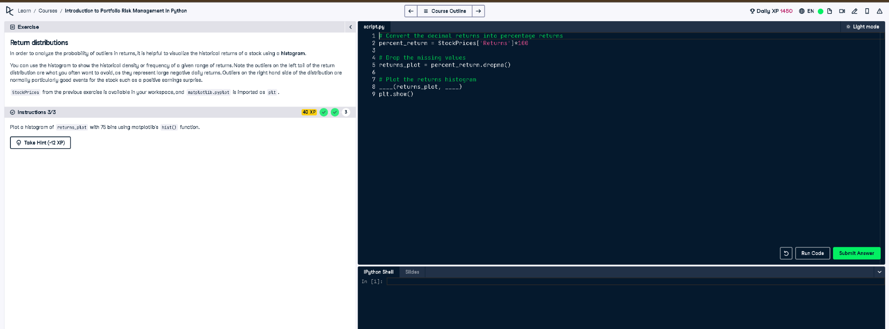

## Full Python Code:

# Convert the decimal returns into percentage returns  
percent_return = StockPrices['Returns'] * 100  
  
# Drop the missing values  
returns_plot = percent_return.dropna()  
  
# Plot the returns histogram  
plt.hist(returns_plot, bins=75)  
plt.show()

## Simple Explanation:

This code first converts stock return values from decimal to percentages by multiplying by 100. Then it removes missing values using dropna(). Finally, it plots a histogram of the cleaned percentage returns using 75 bins with matplotlib to visualize the return distribution.